7/30/2022

Christelle Gihozo

University of Rwanda – CST - SoICT

**Project Report for Web Technology Course**

***Project title: UR Hostel Portal – My project for the Web Technology Course, Department of Computer and Software Engineering – SoICT, University of Rwanda.***

**Submitted by**: 221023182

**Year 2, CSE**

**Academic year 2021-2022**

Table of Contents

LIST OF FIGURES 2

1. Introduction 3

1.1 Project Summary 3

1.2 Problem statement 3

1.3 Objectives 3

1.4 Project Rationale 3

2. Methodologies and Methods 3

2.1 Data collection methodology 3

2.2 Tools to be used 4

2.2.1 Hardware tools 4

2.2.2 Software tools 4

3. System Analysis and Design 4

3.1 Requirement Specifications 4

3.1.1 Functional requirements 4

3.1.2 Data Requirements 4

3.1.3 User Requirements 5

3.1.4 Security Requirements 5

3.1.5 Non-functional Requirements 5

3.2 System Design 5

3.2.1 System overall architecture 6

3.2.2 System information flow 6

4. System Implementation 6

4.1 Landing page 6

4.2 Login page 6

4.3 And so on, at least 5 pages of you **Error! Bookmark not defined.**

5. Conclusion 9

6. Recommendation 10

7. Appendix 10

# LIST OF FIGURES

Figure 1: Overall structure 6

Figure 2: Project landing page 6

Figure 3: Login page 7

Figure 4: List of users **Error! Bookmark not defined.**

Figure 5: User details **Error! Bookmark not defined.**

Figure 6: Edit option **Error! Bookmark not defined.**

# Introduction

## Project Summary

My project is about designing an adequate and timesaving hostel portal for the University of Rwanda students; entitled My UR Hostel Portal. The Portal will be accessible to every interested UR student, where they will have to sign up for their first time using the Portal to be able to use it entirely; for returning users, they will just have to login. After their login, they will be able to register their interest in wanting a hostel room. In doing so, they will answer so crucial questions that will be used to adequately allocated them. For examples; Do you have any chronicle diseases? Do you require special care? Do you have any disability? Are you incoming or continuing student? Etc. With these data,

## Problem statement

University of Rwanda students face the problem of finding a hostel room to stay while studying because the process is long and tiresome. In addition to that, there’s unfairness in the selection process and allocation of rooms. A student has to first apply through a google form provided by the University. After some weeks, a list of selected students is published and the selected students are told to pay for the hostels. Later on, a specific date is set to be the hostel allocation day; the students call it the dooms, day because one spends the whole day on a long and tight queue, being turned side to side and at the very end, some students are not allocated with rooms. It may even take weeks for those students to get a room even if they already paid for those rooms. This is frustrating academically and psychologically for the students and it is inadmissible

## Objectives

My UR Hostel Portal objectives are:

* To adequately allocate the University of Rwanda students from different background with hostel rooms.
* To be user-friendly in the best possible way.
* To be a timesaver web application.

## Project Rationale

Importance of My UR Hostel Portal solution to its Beneficiaries (both the UR students and UR hostel allocators) is that they will benefit of a fast, adequate and organized host allocation process with an efficient and fair completion.

# Methodologies and Methods

## Data collection methodology

I know the problem because myself, I have encountered it for the last two years in UR. By experience, observation and through data collection, I was able to epistemologically conclude that Hostel allocation in the University of Rwanda is a problem that needs a solution.

## Tools to be used

### Hardware tools

The required hardware tools for My UR Hostel Portal are a computer, smartphone and their accessories i.e., charger

### Software tools

The required software tools for My UR Hostel Portal are a browser for testing my website, code editor to write my codes (Visual Code was the one used), Xampp.

# System Analysis and Design

## Requirement Specifications

### Functional requirements

Functional requirements define what a product must do and its features and functions.

1. **User Authentication Module**

It is a plug in that collects user information such as the UR email and password, and compares the information entries in my database.

For example, on the log in page, if there are incorrect credentials then the system will disable a message like “the username or password were incorrect”

1. **User Registration module**

It allows various permissions to be set for the user such as Login, Logout and even register.

The creation of a new account will require the user to use the UR emails, with the following form [lastname_registrationnumber@stud.ur.ac.rw](mailto:lastname_registrationnumber@stud.ur.ac.rw), otherwise it will not allow the user to sign up.

### Data Requirements

The data required for the system to be operational i.e., personal information and others, will be directed into the system databases that I have created. The Entity Relation Diagram of those tables is shown below:

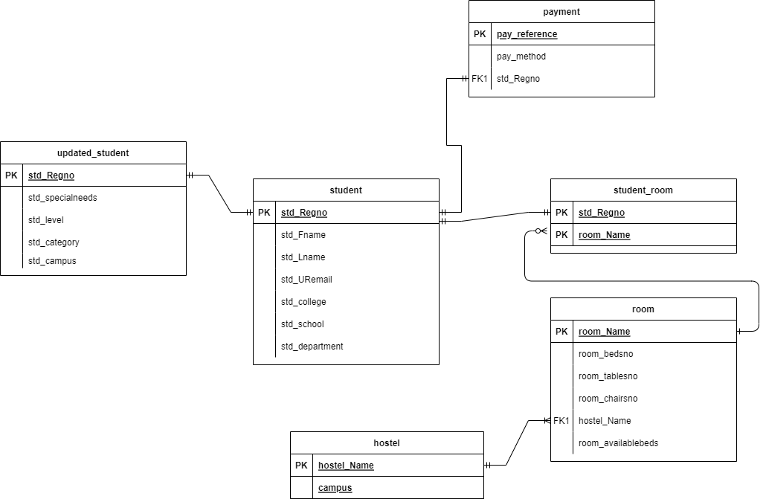

### User Requirements

The users should be able to create their account using their UR emails.

The users should be able to register their interest in wanting hostel rooms.

The users should be able to update information like their payment status.

The users should be able to cancel their application before its completion/termination.

### Security Requirements

As a security mean, my project is Password encryption based. To be able to log in a password will be required know only by the user.

### Non-functional Requirements

The system performance of “My UR Hostel Portal”: The system should be able to handle twenty thousand users without the performance deterioration.

The system reliability of “My UR Hostel Portal”: The website pages should load in three seconds with the total number of simultaneous users being less than four thousand.

The system accessibility of “My UR Hostel Portal”: the system should be able to work an disable its features in a smartphone as well as it does on a computer.

## System Design

### System overall architecture

* E.g.: overall system flow.

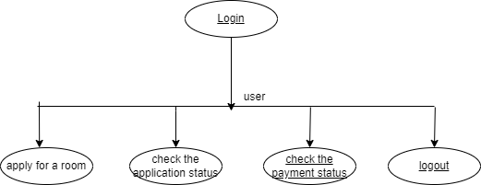

Figure : Overall structure

### System information flow

# System Implementation

## Landing page

This picture details the landing page of My UR Hostel Portal. From this page you can see what is needed to create an account for the first-time users, and the login option for returning users.

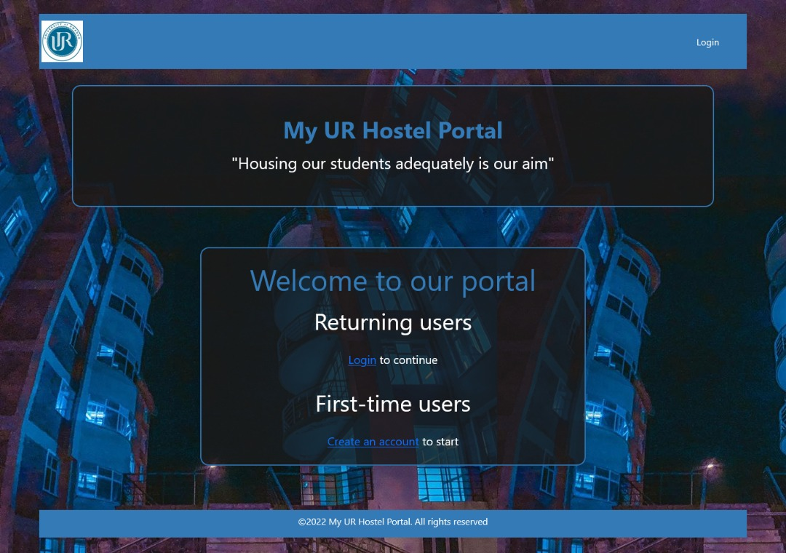

Figure : Project landing page

## Login page

This page details the login process of the portal.

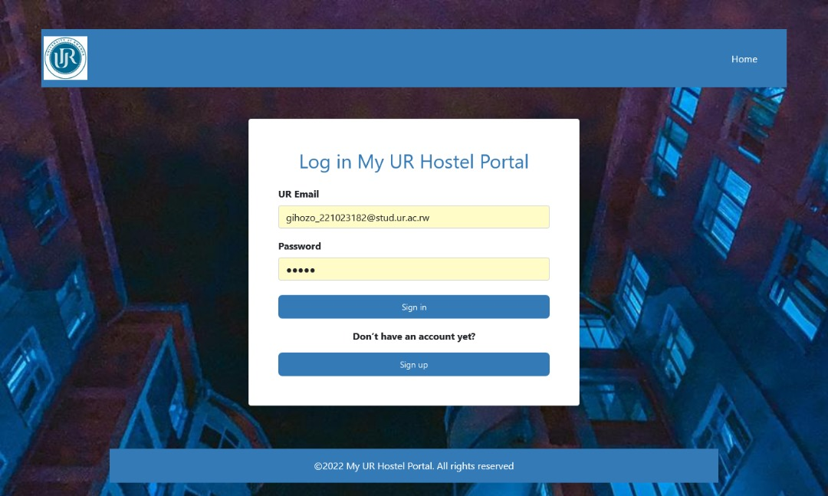

Figure : Login page

## Sign up page

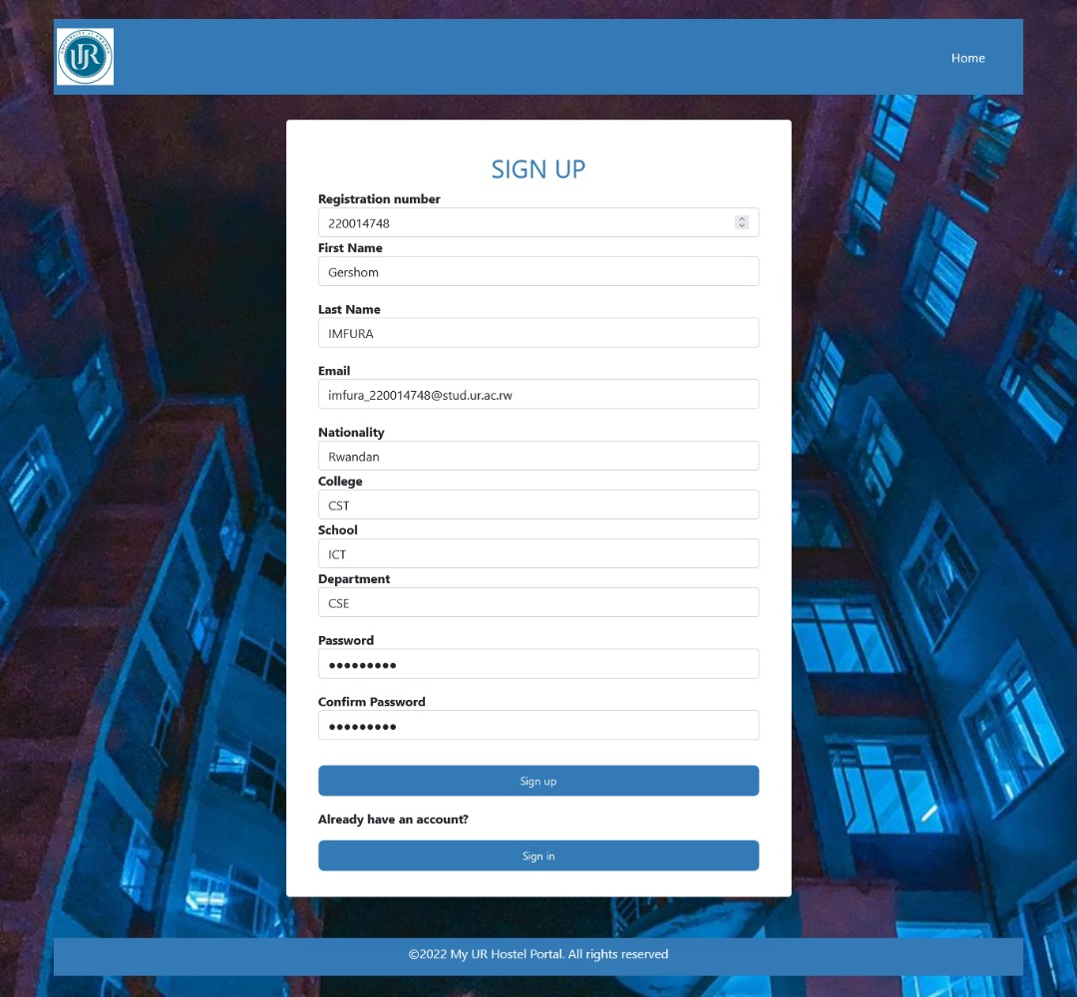

This page details the sign-up process where if the user uses the correct UR email, an account is created.

Or else an error is generated.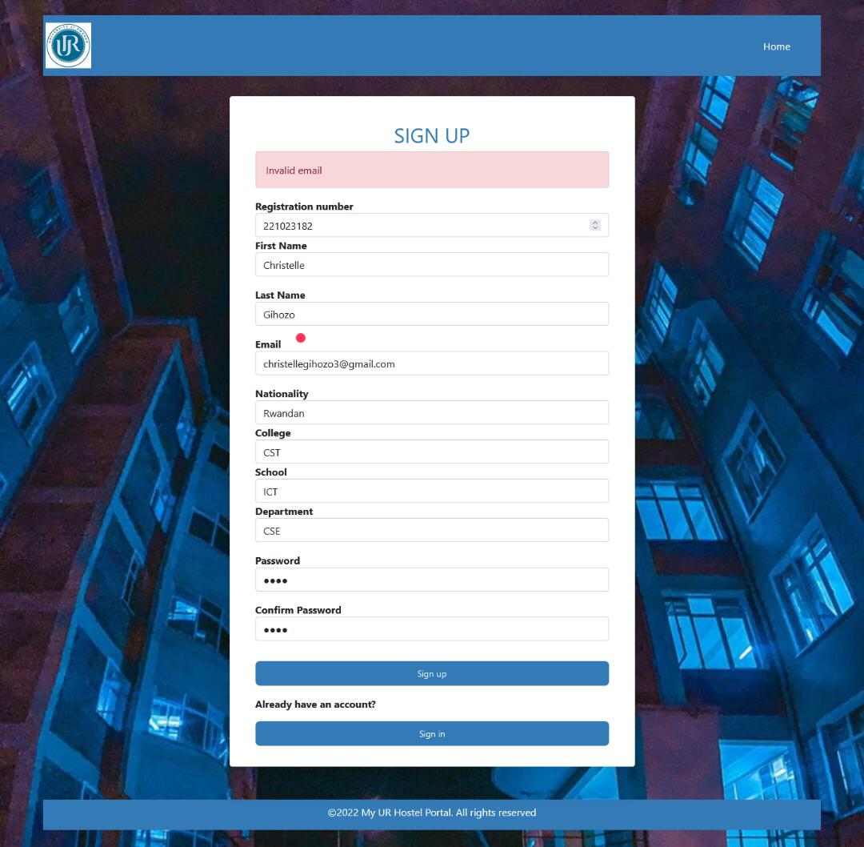

# Conclusion

My project was about providing an adequate and timesaving Hostel Allocation Process through the UR Hostel Portal. I want to solve two main problems, which are the wastage of time and unfairness in the process of being selected and being allocated with hostel rooms. Since they won’t be any need to go and wait for two straight days on a queue to get the keys of the room they paid for, and with the risk of not getting the room. Since the system will automatically allocate the students to their rooms, they will be less unfairness compared to the current process.

# Recommendation

My main goals were to eradicate the wastage of time and unfairness in the process. My project will eradicate the first problem at a high rate, but it will eradicate the unfairness in the process at a moderate rate because the unfairness is present at two levels, the selection level and the allocation level. At the allocation level, the unfairness will be highly eliminated because the system will automatically allocate the students (since every selected student who has paid for the hostel room will get a room) but at the selection, the unfairness will still reside unless we use Artificial Intelligence to prevent the implication of humans in the process.

In addition to that I have learnt how to create a database using MySQL, how to link a JavaScript file to html, how to make an operational website using different languages.

I recommend:

1. **Other students** to advocate for my project since it was mainly designed to improve their campus experience which affects their academic performance.
2. **Department** to help me with further improvements on my website to gradually change their system in hostel allocation.

# Appendix

<https://github.com/Gihozo23/Hostel_Allocation.git>